The ice
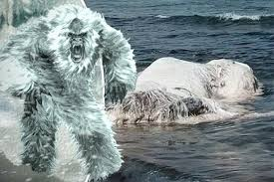
Hairy was lagging along the seabed. He was strong, wide and one eyed. He was hungry so he thought he would go up to the beach. He called at the shop because he liked people. When he was walking up to the end of the water. It was like a mirror. Then he hit something hard it was ice. He thought it was a fish but it was not. So he tried to shoot it with his ice bullets. It hit him instead. So he charged at it with his horns. The ice broke and he got food.

BY JOE

